**31271 Database Fundamentals Database Design Assignment – Spring 2019**

Gianni Pessotto (13199219) & Daniel Boustani (13207509) Tutorial:Wrk1 Activity:02

<https://www.mcgrath.com.au/>

**Part A:**

**Case Study Overview:**

The case study in question conducted was on McGrath Real Estate, an online real-estate agency that performs buying, selling, renting, property agents and home loans through their broker, Oxygen. Their offices and operations are spread throughout New South Wales, Australian Capital Territory, Victoria and Queensland.

To perform any of these operations mentioned above, it is very simple. Customers simply need to select the correct link either from the top of the screen or select the drop down list and specify the information for the operation they are performing. Information required is simply what the customer wants to do e.g. buy, sell, rent or holiday rent. The postcode/area or suburb of where they want to search and finally what type of property they wish to view. Property viewing ranges from any small residential to commercial across the 3 states. (refer to figure 1)

Conversely, an agent or office can be contacted by searching for the closest one and contacting them via information provided to arrange for a meeting to aid customers in their property issues.

**(Figure1)**

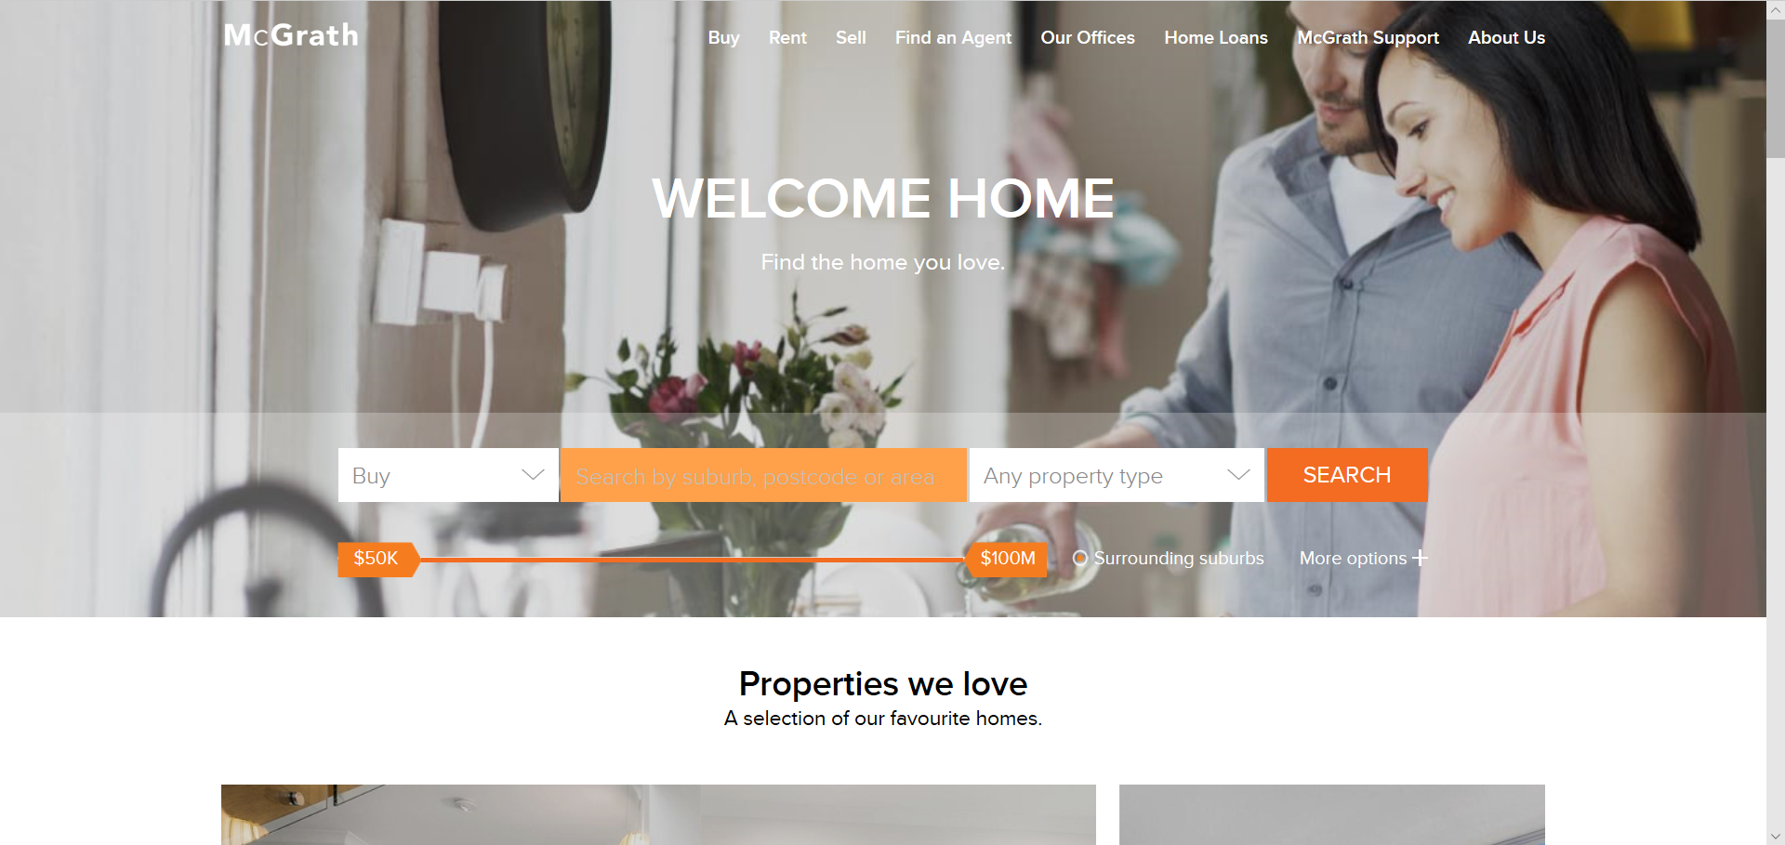

After the option has been selected and all required information has been entered, the search is initiated. The customer can then view the details surrounding the property or entity in question. For example, when buying a house.

**(Figure 2)**

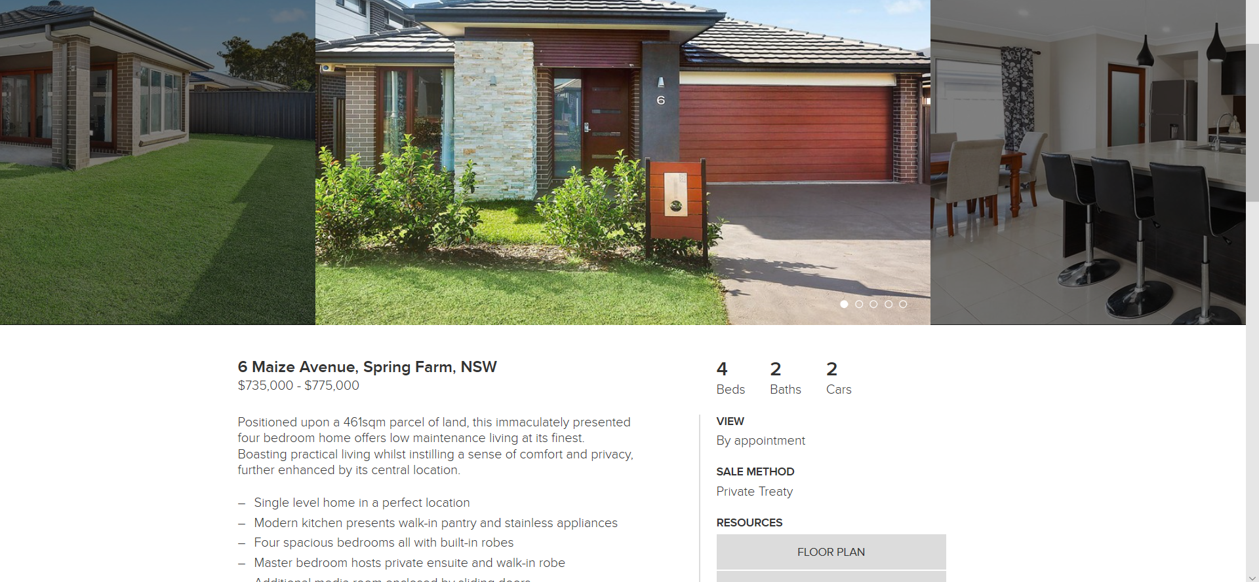

From here, customers are given many resources and options such as contacting the agent responsible for selling the property, viewing the floor plans, details for the house etc that will help them in buying or renting properties.

**Database Functions:**

The database must track many different entity types and their attributes associated such as property price, location/address, agent responsible etc. Indexing for all properties in their respective categories (buy, sell, rent and holiday rent).

property information must be instantly updated and must also be correct to avoid confusion as the information may change quickly such as if the property was sold, rented etc.

Agent information as well as office information must always be findable and referenceable.

The data collected will consist of the customer’s name, email, phone number and address.

All customer data will be entered after bookings with agents or offices to ensure only potential customers are kept in the database to reduce the amount of useless and/or redundant data.

Returning customers must be recognised by the system so staff can offer fresh and relevant advice for their situation after extracting their previous files.

Filters when searching must be completely accurate and no duplicate data should appear.

The Oxygen loan calculator will need to be kept up to date and accurate

The database will also log customer questions/help requests.

**Database Requirements:**

Users/customer- Those viewing the system and have made a booking who have serious interest in property. Unique ID is based on entirely new attribute, customerID

Attributes- customerID, email_address, first_name, last_name, phone_number

Buy- All properties available for sale. The unique identifier is BP (buying property).

Attributes- BP, suburb, postcode, area, price, property_type, bathrooms, bedrooms, parking, address, situation

Sold- All properties that have been sold. The unique identifier is OffS (off selling).

Attributes- OffS, suburb, postcode, area, price, property_type, bathrooms, bedrooms, parking, sold_date, address

Rent- All properties available to be rented out, unique ID is RnP (Rental property).

Attributes- RnP, suburb, postcode, area, price per week, property_type, bathrooms, bedrooms, parking, listed_date, address

Holiday renting- All properties available to be rented out for holiday periods. Unique ID is HRP (Holiday rental property).

Attributes- HRP, suburb, postcode, area, price per week, property_type, bathrooms, bedrooms, parking, listed_date, address,

Agents- Staff who interact with customers on property matters. Unique ID is agentID.

Attributes- agentID, staffID, fname, lname, division, location, department

Booking- Customers arrange a meeting with an agent to discuss property matters. Organised via time.

Attributes- staffID, book_date, book_time, customerID, officeID

Support- Staff who interact with customers that have problems/issues that need to be cleared up. SupportID is unique staff that are to resolve issues.

Attributes- supportID, phone_number, fname, lname, officeID, staffID, department

Offices- Main offices where customers meet with staff for their bookings. Each office is uniquely identified by its own number.

Attributes- officeID, office_address, office_number, state, suburb, postcode, area, staffID,

Staff- Employees of the business including agents.

Attributes- staffID, agentID, officeID, state, fname, lname, department

**Business Rules:**

1. Customer and their details (name, address, email, phone number) added to system after booking with agent or office.
2. Customers will be uniquely identified via email.
3. All information relative to properties must be available.
4. Descriptions of property must not be biased or misleading.
5. Can’t hide any information within database.
6. Agent information must be available at all times.
7. Office information must be available at all times.
8. Property already sold or currently being rented cannot be bought or rented out to another tenant.
9. The website must include information about the business and our operations.
10. The Oxygen loan calculator will need to be kept up to date as it uses real-world information from banks. However this information will be given by Oxygen so collection is not necessary, only organisation.
11. Bookings have multiple options available.
12. Must have a functioning support system to aid customers.